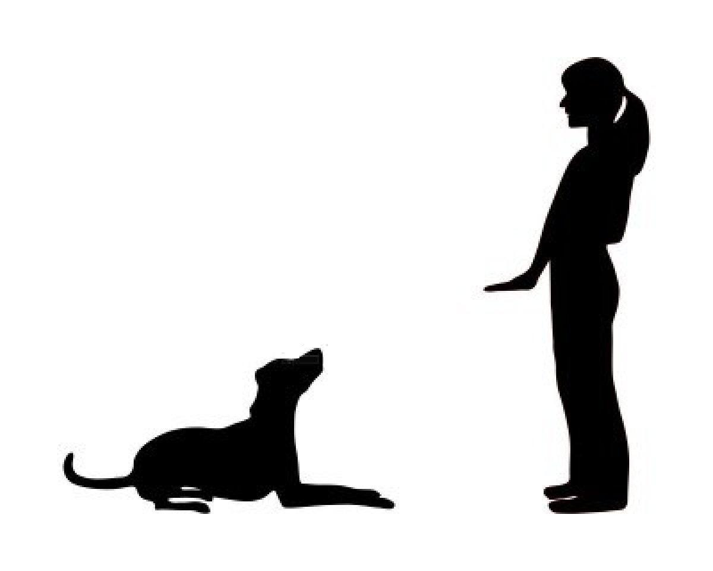

Week 3 – Rally-O Class

Good job in class everyone! Please see the movements below to help guide you as you work at home this week. Check out the YouTube demos for reference. These are the final movements for the course, practice all the signs we’ve gone over in class for next week's competition!

Diagonal Left

As you approach this sign your dog should be at your side. You and your pup will walk in a diagonal line to the left, he/she should remain at your side through the movement. Practice keeping your pup in the heel position.
https://www.youtube.com/watch?v=TJK6k3XsQos&ab_channel=AKCObedience%26Rally

Spiral Left – Dog Inside

During this movement you will enter from the right side of the first cone and circle around the cones together with your dog. You and your pup will circle all three cones, then circle the first two cones, then circle the first cone and exit to the left. Practice to maintain a loose leash and your pup in a heel position next to you. You do not need cones to practice at home line up anything of a similar size.
https://www.youtube.com/watch?v=kN_AF6x8hAA&app=desktop&ab_channel=AKCObedience%26Rally

Left About Turn

As you approach this sign your pup should be at your side. You will make an about turn to the left, at the same time your dog will move around you to the right and return to your side. Practice using treats and a leash to encourage and shape this movement.
https://www.youtube.com/watch?pbjreload=101&v=WgjsubQbW6M&app=desktop&ab_channel=AKCObedience%26Rally

Send Over Jump

During this movement your pup will jump over the hurdle while you pass alongside them at the same time without stopping.
https://www.youtube.com/watch?v=1osSl9QQsYI&ab_channel=AKCObedience%26Rally

Finish

This sign marks the end of the course, time stops. Congratulations! https://www.youtube.com/watch?pbjreload=101&v=401oeHGNqUk&app=desktop&ab_channel=AKCObedience%26Rally

