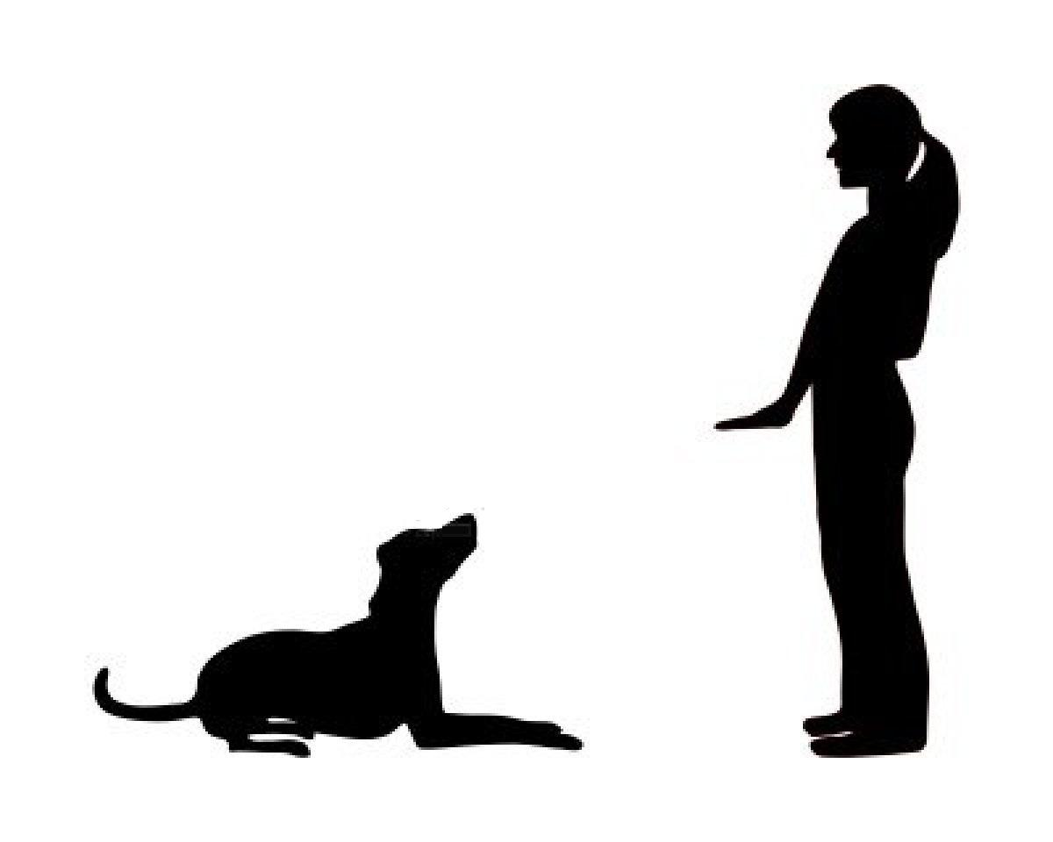

Week 2 – Rally-O Class

Good job in class everyone! Please see the movements below to help guide you as you work at home this week. Check out the YouTube demos for reference. We will be adding 5 more to next week’s class so be sure you are comfortable with performing these.

Loop Left

During this movement you and your pup will loop left and cross over your original path diagonally, your dog should stay at your side for the entire movement. Practice keeping your pup in the heel position. https://www.youtube.com/watch?v=TRR1YWsWxXQ&list=PLpkaTxdGkvI3lFUBckw-NS4BXxVBzwK1_&index=39&ab_channel=AKCObedience%26Rally

Halt – 1, 2 and 3 Steps

As you approach this sign your dog should stop when you do and sit at your side. Next you will take one step forward and stop, then two steps forward and stop, then three steps and stop. Every time you stop your pup should sit at your side.
https://www.youtube.com/watch?v=bMVZcnssYdw&list=PLpkaTxdGkvI3lFUBckw-NS4BXxVBzwK1_&index=26&ab_channel=AKCObedience%26Rally

Halt – Down – Walk Around

As you approach this sign your dog should stop when you do and sit at your side. While at your side cue for a down and walk around your pup to return to the original heel position.
https://www.youtube.com/watch?v=UnTxiiLzL3c&list=PLpkaTxdGkvI3lFUBckw-NS4BXxVBzwK1_&index=32&ab_channel=AKCObedience%26Rally

Figure 8

During this movement you will enter from either the left or the right side of the first cone and weave around the cones in a figure 8 pattern. You and your pup will cross the centerline three times before moving on. Continue practice on maintaining a loose leash. You do not need cones to practice at home line up anything of a similar size.
https://www.youtube.com/watch?v=MwGL5Pki8Yw&list=PLpkaTxdGkvI3lFUBckw-NS4BXxVBzwK1_&index=33&ab_channel=AKCObedience%26Rally

Right Turn

As you complete your turn your pup should be at your side not crowding you or pulling on the leash. Strive to perform a nice sharp right turn this time! Using a treat to lure your dog’s nose away from your leg may be helpful during the teaching phase.
https://www.youtube.com/watch?v=H9Q7Fc_RcEI&list=PLpkaTxdGkvI3lFUBckw-NS4BXxVBzwK1_&index=7&t=0s&ab_channel=AKCObedience%26Rally

