Shelter Enrichment
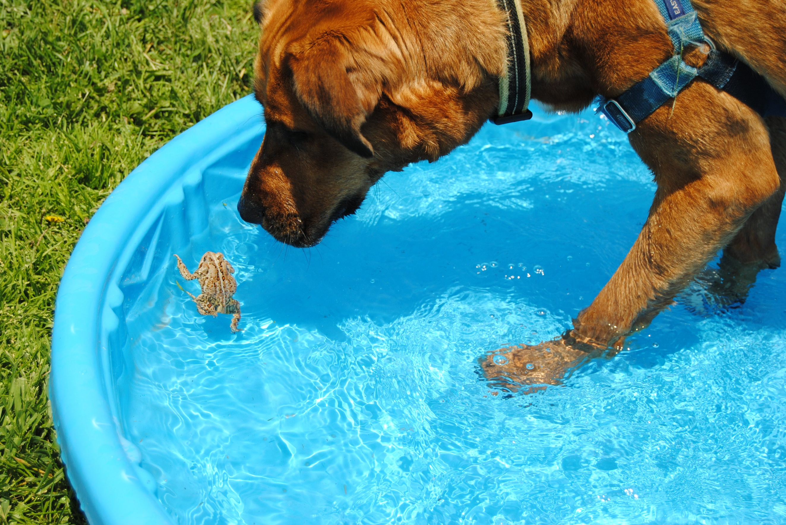

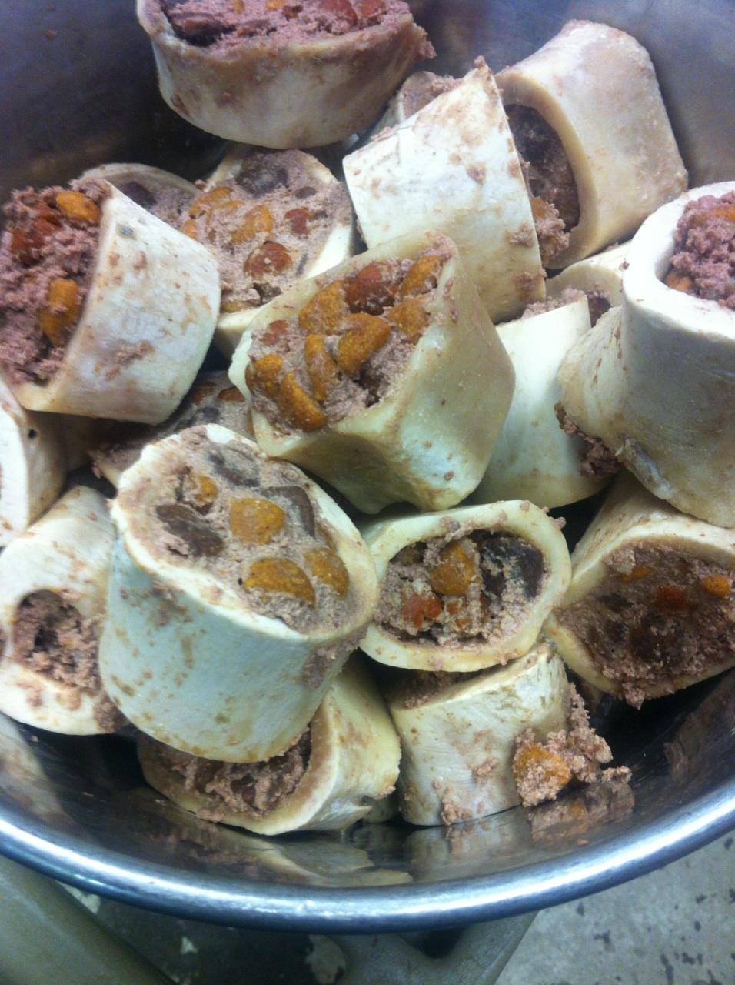

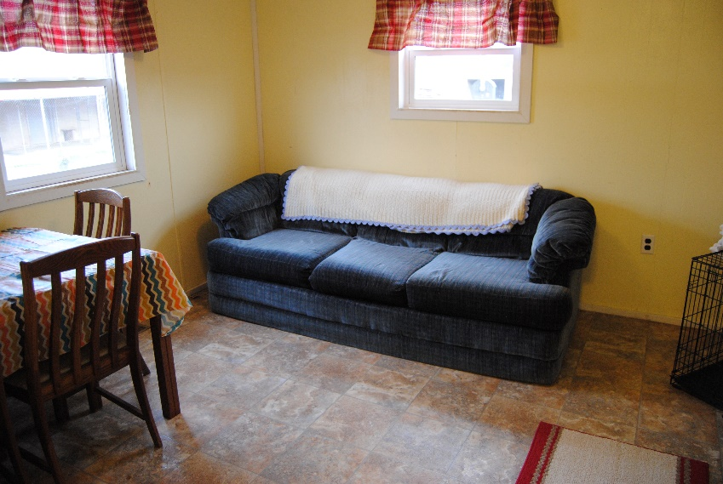
Enrichment is one of the most important aspects in making the lives of our animals more fulfilling and enjoyable. We spend time with our dogs at home: walking them, brushing them, training them, and, overall, just spending one on one time with them. Shelter animals need the human touch and care as well. They need daily physical and emotional stimulation to deal with the stresses of kennel life. Stresses include loud noises and lack of sleep, all of which affect their behavior and adoptability. While we strive to provide each animal with love and care, shelter life is not an ideal living condition for any animal. We are always working to prepare them for the day that they are adopted and move into their forever home.
Contents
Dogs 4
1. Visual 4
2. Auditory 4
3. Olfactory 4
4. Tactile 5
5. Edibles 5
6. Chewables 6
7. Behavioral / Multiple 7
7
Cats 10
1. Visual 10
2. Auditory 10
3. Olfactory 10
4. Tactile 10
5. Edibles 10
6. Chewables 10
7. Behavioral 10

Dogs

Visual
  - Bubbles
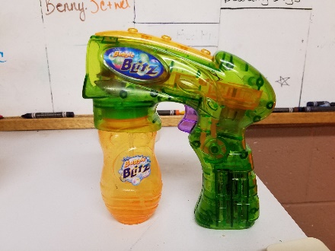

Auditory
  - Music

Olfactory
  - Sprays - Daily scents can be sprayed on dogs’ blankets. This gives the sense of something different to focus on rather the same smells of other dogs and hundreds of scents picked up daily.
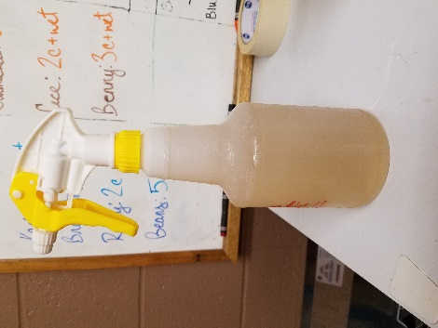

  - Scent Sticks are PVC sticks with holes filled with natural elements that the dogs can play with to help relieve the stress of kennel life. Sticks can be hung from the ceiling which provides the challenge of trying to reach the stick; this challenges the dogs’ mental wellbeing.



Tactile
  - Blankets and Kuranda beds provide a comfy place for pups to rest.

Edibles
  - Stuffed Marrow Bones

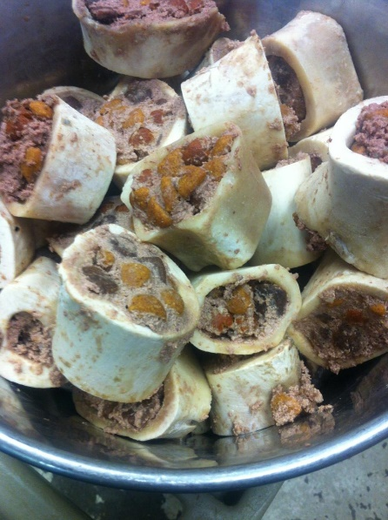
This does double duty as an edible AND chewable and our dogs LOVE it!
Recipe:
- Hollow marrow bones
- Dry dog food
- Wet dog food
- Broth or water

Mix and pack into bones
Enjoy!

  - Food Dispensing KONGS, toys and Puzzles – there are varying levels of difficulty from easy to challenging for the expert dog brain!

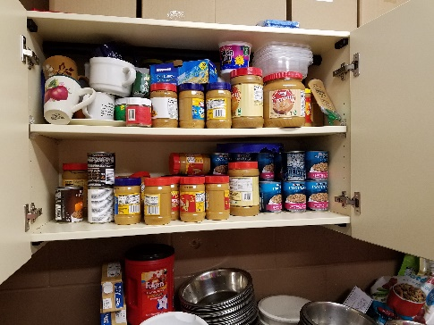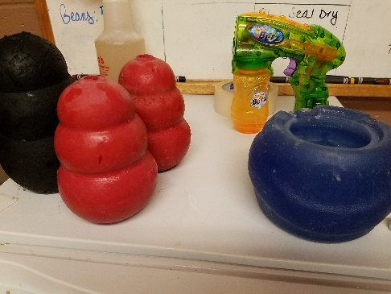

  - Stuffed Apples
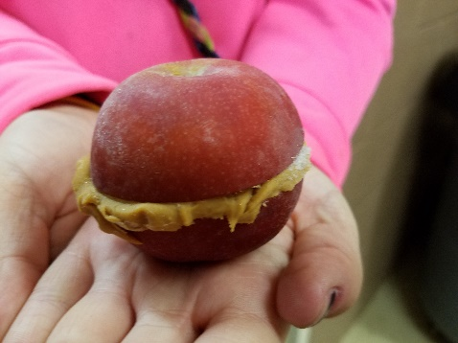

Chewables
  - Various natural chews 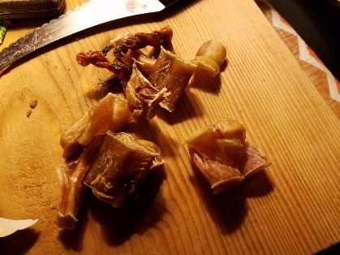

Behavioral / Multiple
  - Pool of bottles
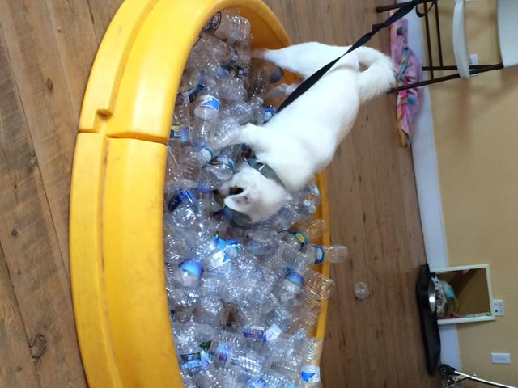

  - Training and Behavior Classes
    - Petiquette – weekly group manners class with volunteers. (Gretchen Knittel)
    - STORC (Gretchen Knittel)
    - Playgroup Class – combination of play time and structured on leash commands and loose leash walking are taught
    - C.L.A.S.S. Program
    - Doggie Day Out – day trips to parks and towns
    - Pack Walks & Sniffy Walks – Groups of dogs are taken on walks with volunteers. (M. Alexander)
    - Training Club – Dogs attend offsite training classes with volunteers. (Megan Alexander)
    - V.O.I.C.E. – Volunteer Organized in Canine Enrichment. This program teaches volunteers about enrichment and offers them alternatives to just walking dogs. (Hud Durrah)
  - Playgroups
    - Dogs Playing For Life Manual
    - Match Up II Doggie Social Hour Manual

  - Real Life Room

Create a space which mimics a typical home.
Used for dogs to spend time in, away from all the noise of the kennel.
Can be used to help with housetraining.

  - Calming Sprays
    - D.A.P. Dog Appeasing Pheromone
    - Adaptil
  - Kennel Sit-Ins – staff and volunteers spend time with the dogs in there kennels.
  - T-Touch
  - Car Rides
  - Play Yard Time / Swims / Agility work
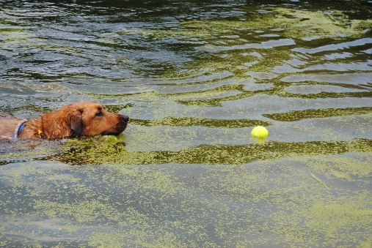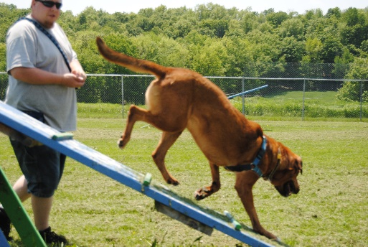
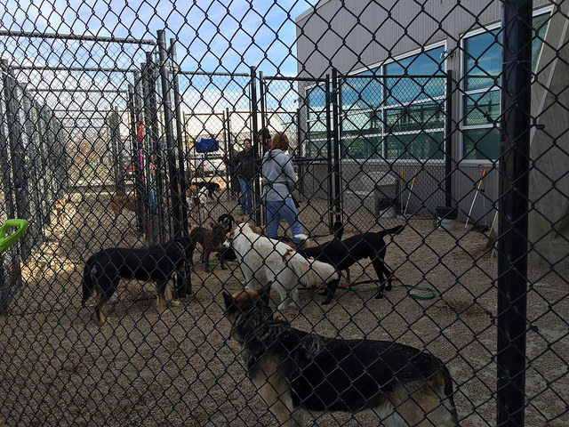
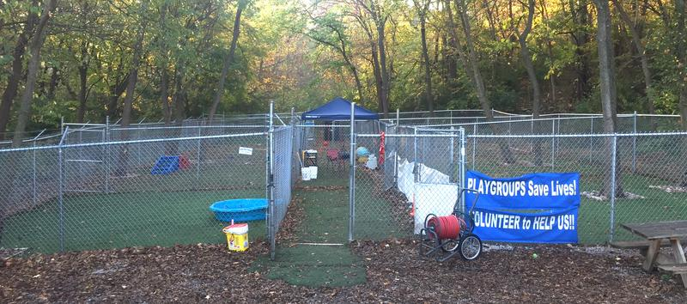

  - Enrichment Board – make a plan for all your dogs to include the various forms of enrichment you implement.

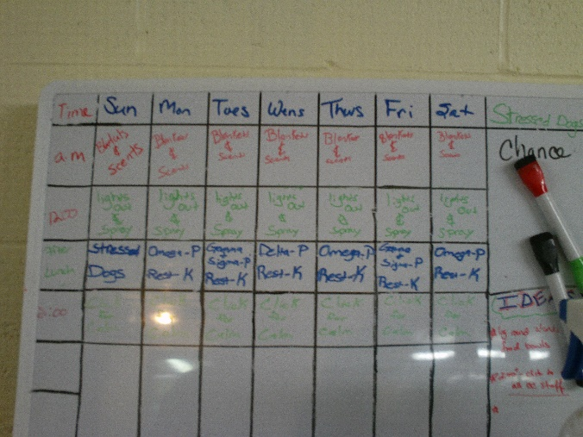

Cats

Visual
  - Bubbles
  - Aquariums
  - Bird Feeders

Auditory
  - Music

Olfactory
  - Sprays
  - Scent Sticks

Tactile

Edibles
  - Stuffed Mini Kongs

Chewables

Behavioral
  - Exercise wheels

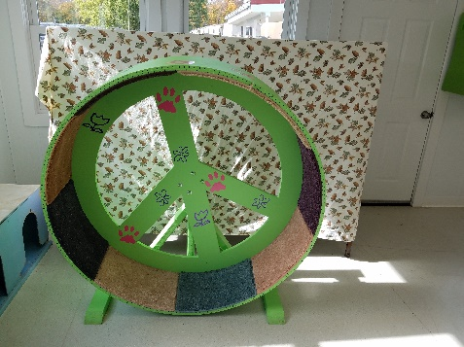

  - Real Life Rooms and Climbing Stations

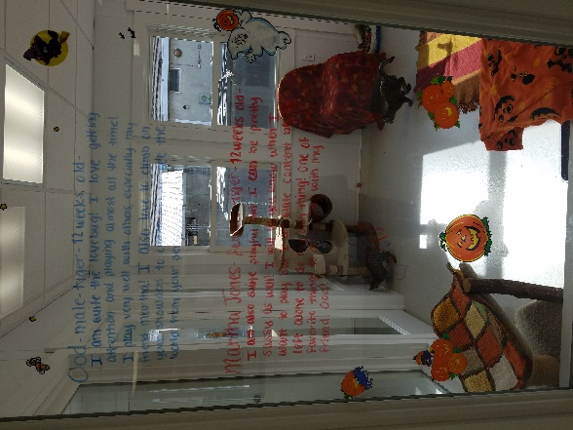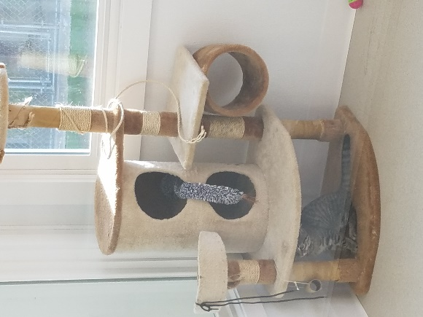

Contributors to the start of this enrichment document and mentees in
Trish Loehr’s 2016 Shelter Mentorship Class

Megan Alexander – Sonoma County Animal Services, CA
Hud Durrah – Kansas City Pet Project, MO
Connie Dwyer – Animal Care Sanctuary, PA
Royal Foss – Berkeley Animal Care Services, CA
Delyse Gannaway – Sacramento County Animal Shelter, CA
Gretchen Knittel
Katy Mahaley – Asheville Humane Society, NC
Clare Southgate – Calgary Humane Society, AB
Shane Stanis – Contra Costa Animal Services, CA
Dawn Stone
Mara Velez – Contra Costa Animal Services, CA
Sarah Wharton - Albuquerque Animal Welfare Department,NM

